ENG200010 Engineering Technology Design Project
Assignment 7
Dang Khoa Le
Student ID: 103844421
Major: Bachelor of Software Engineering

Abstract— This document presenting the demonstration of the Assignment 7, Create a VI file for an automatic parking lot system design of IR sensor and Servo Motor integrating with NI-DAQ system.
I. System layers:
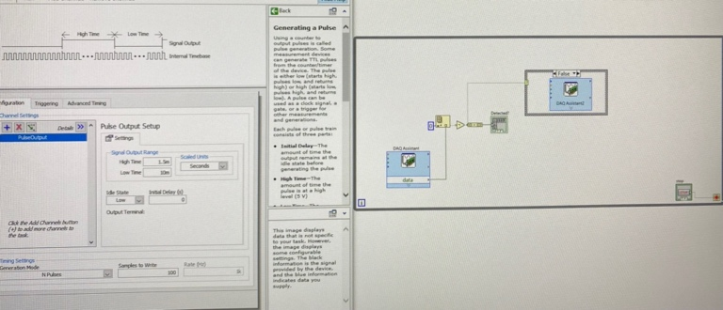
The VI design consist of some fundamental components including Boolean (Not), Array functions (Index Array, Build Array) and Case Structures that align 2 Servo Motor stages, connected to a NI-DAQ interface – Servo Motor and IR sensor.

1. Set Up:
The majority of the system’s components are allocated inside the While loop, which can be aborted by using the ‘stop’ button, linked directly to the loop condition.

By using the 3 DAQ Assistances in LabVIEW, the design is capable to interface with the NI-DAQ module and allows connection between the IR sensor and the Servo Motor. The IR sensor is connected to pin 1 (DAQ Assistance), and the Servo Motor connects to pin 3 or DIO3 (DAQ Assistance2 and DAQ Assistance3).

2. System Analysis:
Using Index Array function, we can convert 1D array of IR sensor’s input value into Boolean T/F value which could change the case-value of the Case structures between True and False.
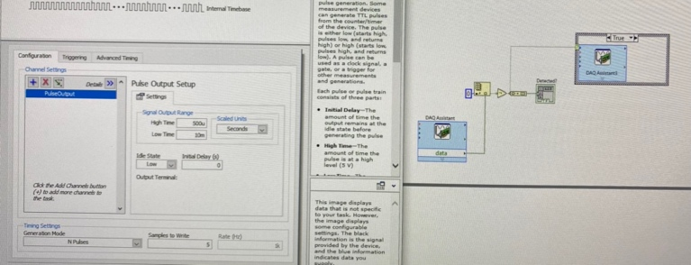
In the True case, the Servo Motor will align their bump gate to rotate at 90 degree or at horizontal direction, while at default case with no sensor-value, the False case will change the gate back to be at initial 0 degree or horizontally aligned.

II. Ni-DAQ System:
The first DAQ Assistance consist of Digital line input of IR sensor signal. The second Ni-DAQ interface (DAQ Assistance2) on the False Case structure has pulse output data of the bump gate at horizontal direction (0 degree), at which case, the configuration consist of High Time 1.5m and Generation Mode – ‘N Pulses’. The third Ni-DAQ interface (DAQ Assistance3) on the True Case structure has pulse output data of the bump gate at vertical direction (90 degree), at which case, the configuration consist of High Time 0.5m and Generation Mode – ‘N Pulses’.

III. Testing Components (Additional):
I have to implement a ‘Not’ Boolean component to make the default case of the IR sensor detector to be False.

The design also consist of a testing LED array that lights up when detecting IR sensor signal. A Build Array function has been implemented to convert T/F (Boolean) data into Array data that lights up the testing LED.

